

TProfessor Andy Ruina
Team Advisor
Theoretical and Applied
Mechanics
309 Kimball Hall
Cornell University
Ithaca, NY 14853
Phone: 607.255.7108
Fax: 607.255.2011
ruina@cornell.edu

Brett Lee
Team Leader
210 Lake St. Apt. 4I
Ithaca, NY 14853
Phone: 607.256.1038
bjl16@cornell.edu

Walter Rivas
Business Manager

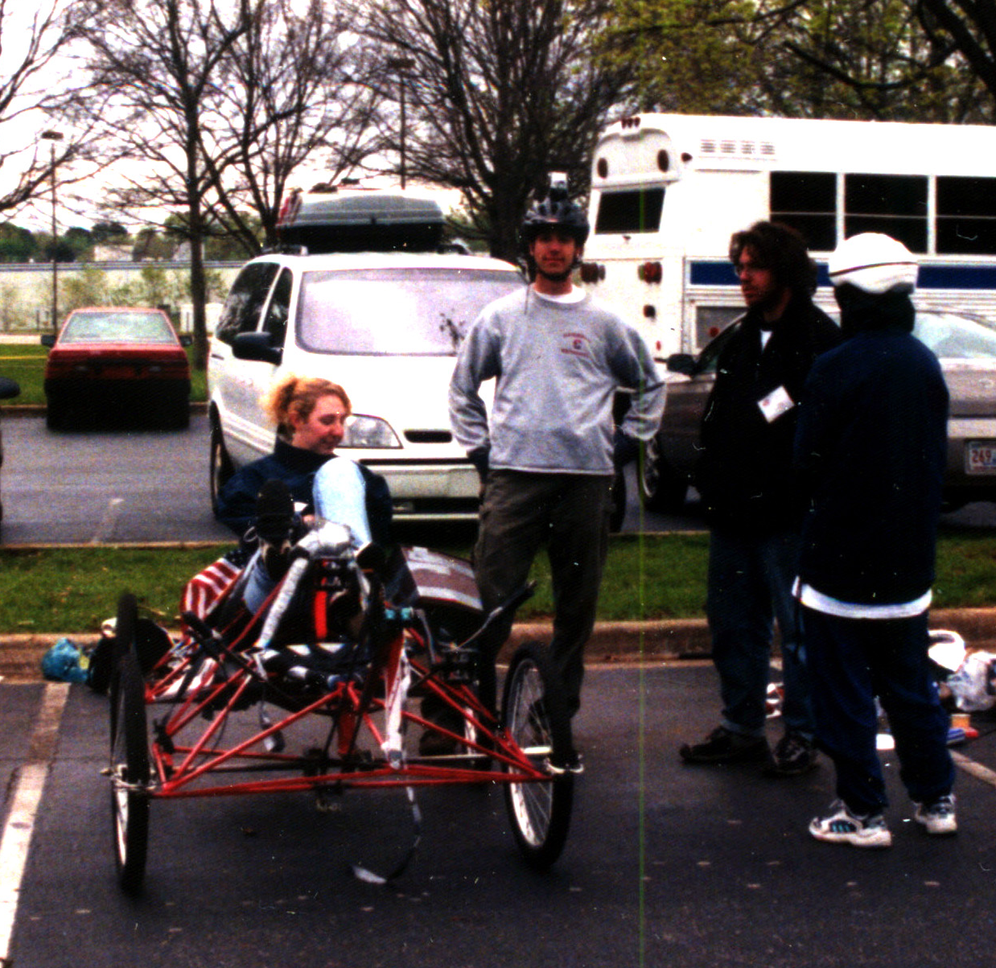
he objective of the NASA-sponsored moonbuggy competition is for a co-ed team of college students to effectively design and build a two-person human-powered vehicle to race over a simulated lunar course in the fastest time possible. Aside from a few minor engineering requirements involving ground clearance, turning radius, and disassembled volume, there are no stipulations as to how this objective is to be achieved.

Because of the freedom given to implementation, our team is excited about our entry in next year’s competition. It presents the perfect arena for unbridled creativity and an excellent opportunity to test new concepts, materials, and construction techniques. Several factors must be weighed, among these are the advantages and disadvantages of various engineering principles, issues regarding complexity versus potential performance gains, improved functionality versus fabrication time, and of course the costs for equipment and materials.

Last year was Cornell’s first entry into NASA’s Moonbuggy competition. Approximately 25 teams competed in the university division in addition to the high school entries. Most of these teams have been participating since the competition’s inception and have

significant experience with the course obstacles and the construction of the moonbuggies. The 2001 race will be held at the United States Space and Rocket Center in Huntsville, AL on April 6th – 7th.

The ‘00 team consisted mostly of Mechanical Engineering students. This year we have significantly expanded to more than double our original size and now include engineers in various disciplines ranging from Engineering Physics to Computer Science. Because of this diversity, each member can bring new ideas from his or her own respective field that will further increase our knowledge base and provide us with more options for the competition. Our advisor on this project is Dr. Andy Ruina, professor of Theoretical and Applied Mechanics at Cornell University. Professor Ruina also heads Cornell’s Human Power Lab.

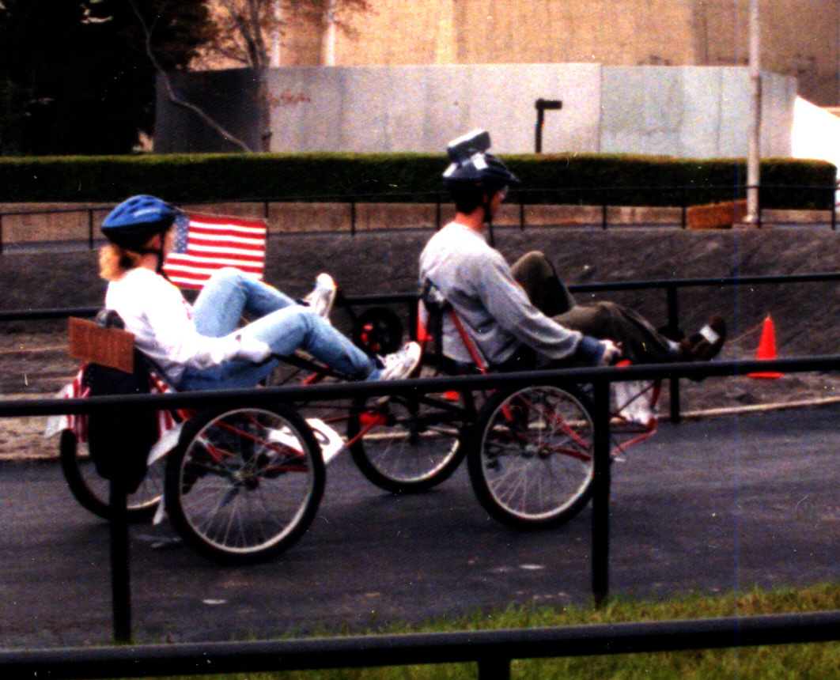
Our design this year will build off the experience gained during our first foray into the competition. We are operating under the principle that the best designs come from the cycle of trial, error, and correction. Regular meetings were held over the summer and we have already settled on the basic methods that will be used to meet the challenges of steering, suspension and drive train. The process of finding engineering solutions that will allow us to practically implement these systems into a working buggy has already begun.

The biggest driving factor in our design for the new buggy is the desire for innovation. One of the first things we noticed at the competition was the overall similarity of concept among the buggies that performed well. We resisted the temptation to emulate their designs simply because “it worked for them.” We feel strongly that our concept can be improved to the point where it is as good or better than the proven design. In our opinion, this is the bigger technological achievement than simply showing up with another look-alike.

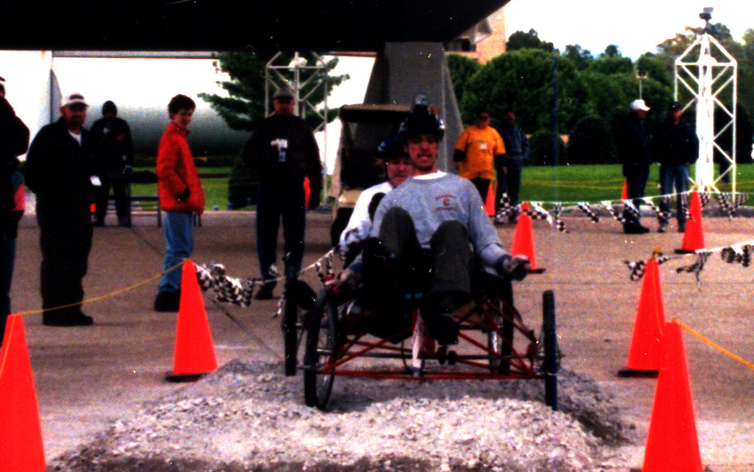
Although we did not win, our first venture into the competition was still a successful one nonetheless. We made many experiential observations which are now playing a major role in the design of our second-generation buggy. Funding for our first buggy came solely from Cornell and was done on short notice. This year we’ve started months ahead of the competition and are now seeking corporate assistance for the next phase of the project. We are approaching you for both financial assistance as well as engineering guidance. Although we cannot guarantee a victory in the competition, we can, however, guarantee that this aid will not be for naught. The knowledge gained from this competition is priceless. The experience is the equivalent of on-site training with the application of the knowledge gained while in college. Successful companies need employees with hands-on, project experience.

We are currently seeking $7,100 in order to enter the competition with a buggy that we feel best represents our diverse abilities and talents. The capital investment will be used for materials, equipment, lab space, transportation, and so forth. Detailed accounting information will be available at your disposal at any time to provide you with assurance that the funds are being used appropriately. If possible, we would also like to be placed in contact with someone that we can consult regarding engineering issues. It would be preferable if that contact is an engineer but any help you can provide us with greatly appreciated.

We thank you for taking the time to review our proposal. We realize that you receive many similar requests and feel that we’ve presented you with enough information to validate the worthiness of our project. Please fell free to contact us if you have any questions or concerns.

Best regards,

The Cornell University Moonbuggy Team

